**3-Bus 2-Partition Problem**

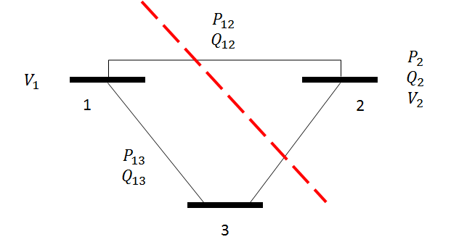

*Bus 1 is the slack.

**Line Parameters**

|  |  |  |  |  |
| --- | --- | --- | --- | --- |
| **From Bus** | **To Bus** | **R (pu)** | **X (pu)** | **B (pu)** |
| 1 | 2 | 0.01 | 0.03 | 0 |
| 1 | 3 | 0.02 | 0.05 | 0 |
| 2 | 3 | 0.03 | 0.08 | 0 |

**Measurements**

|  |  |  |  |
| --- | --- | --- | --- |
| **Measurement i** | **Type** | **Value (pu)** | $\sqrt{R_{ii}}$**(pu)** |
| 1 | P_12 | 0.888 | 0.008 |
| 2 | P_13 | 1.173 | 0.008 |
| 3 | P_2 | -0.501 | 0.010 |
| 4 | Q_12 | 0.568 | 0.008 |
| 5 | Q_13 | 0.663 | 0.008 |
| 6 | Q_2 | -0.286 | 0.010 |
| 7 | V_1 | 1.006 | 0.004 |
| 8 | V_2 | 0.968 | 0.004 |

Partition A:

**Measurements for Area A**

|  |  |  |  |
| --- | --- | --- | --- |
| **Measurement i** | **Type** | **Value (pu)** | $\sqrt{R_{ii}}$**(pu)** |
| 1 | P_12 | 0.888 | 0.008 |
| 2 | P_13 | 1.173 | 0.008 |
| 4 | Q_12 | 0.568 | 0.008 |
| 5 | Q_13 | 0.663 | 0.008 |
| 7 | V_1 | 1.006 | 0.004 |

$$x_{A}={\left[θ_{2} θ_{3} V_{1} V_{2} V_{3}\right]}^{T}$$

Partition B:

**Measurements**

|  |  |  |  |
| --- | --- | --- | --- |
| **Measurement i** | **Type** | **Value (pu)** | $\sqrt{R_{ii}}$**(pu)** |
| 1 | P_12 | 0.888 | 0.008 |
| 3 | P_2 | -0.501 | 0.010 |
| 4 | Q_12 | 0.568 | 0.008 |
| 6 | Q_2 | -0.286 | 0.010 |
| 8 | V_2 | 0.968 | 0.004 |

$$x_{B}={\left[θ_{2} θ_{3} V_{1} V_{2} V_{3}\right]}^{T}$$

Central state estimation solution:

|  |  |  |
| --- | --- | --- |
| **Bus** | **Angle (rad)** | **Voltage (pu)** |
| 1 | 0 | 0.9996 |
| 2 | -0.02177 | 0.9742 |
| 3 | -0.04792 | 0.9439 |

Central Area A solution:

|  |  |  |
| --- | --- | --- |
| **Bus** | **Angle (rad)** | **Voltage (pu)** |
| 1 | 0 | 1.006000 |
| 2 | -0.021251 | 0.980455 |
| 3 | -0.047472 | 0.950798 |

Central Area B solution:

|  |  |  |
| --- | --- | --- |
| **Bus** | **Angle (rad)** | **Voltage (pu)** |
| 1 | 0 | 0.993850 |
| 2 | -0.021788 | 0.968000 |
| 3 | -0.046745 | 0.936129 |

My ADMM state estimation solution for nonlinear h, after 20 iterations, tol = 1e-4:

|  |  |  |  |  |
| --- | --- | --- | --- | --- |
| **Bus** | **Area A Angle (rad)** | **Area B Angle (rad)** | **Area A Voltage (pu)** | **Area B Voltage (pu)** |
| 1 | 0 | 0 | 1.005998 | 0.993852 |
| 2 | -0.021251 | -0.021788 | 0.980454 | 0.968000 |
| 3 | -0.047472 | -0.046744 | 0.950797 | 0.936131 |